Nitte Meenakshi Institute of Technology
Department of Aeronautical Engineering
Subject Name: Aerodynamics II |  |  |  |  | Subject Code: 22AE51A
Learning Assignment 1 |  |  |  |  | Academic Year: 2024-25
Name of the Student |  |  |  |  |  | USN
LOCHANA BC |  |  |  |  |  | 1NT23AE053
NOOR FATHIMA |  |  |  |  |  | 1NT23AE068
PREYA DEVI |  |  |  |  |  | 1NT23AE073
“Problem Statement”

Consider a two-dimensional inviscid steady supersonic flow of air (perfect gas, γ = 1.4, R = 287 J/kg·K) over a sharp 2-D wedge of unit span and reference chord length 1.0 m. The wedge produces a flow deflection θ = 40° (wedge half-angle = 40°). Upstream freestream conditions are p1 = 101325 Pa, T1 = 288 K. Tasks: Analytical: For freestream Mach numbers M1 = 1.75, 2.25, 2.75, and 3.25: Check whether θ = 40° ≤ θ_max(M1). If yes, use the oblique shock θ–β–M relation (weak root) to find β, then compute post-shock normal Mach number and apply normal shock relations. Calculate: β (shock angle), p2, T2, M2, stagnation pressure p0,2, and stagnation temperature T0,2. If θ > θ_max, state that the shock is detached and analytical solution is not possible. Numerical (using ANSYS Workbench or SIMULIA): Perform 2-D steady compressible Euler simulations (inviscid) to capture shock position, shock angle, and pressure distribution on the wedge surface. Compute pressure drag. Additionally, perform 2-D steady compressible RANS (k–ω SST) runs with no-slip wall (if viscous drag is required). Domain: upstream 5 m, downstream 10 m, transversely ±5 m. Apply mesh refinement near wedge and shock. Use a shock-capturing high-resolution scheme (second order). Ensure convergence (residuals < 1e-6 and stable force history). Compare numerical β, p2, T2, M2, p0,2, T0,2, and surface pressure distribution with analytical results. Report whether shocks are attached or detached for each M1, and compute drag coefficients.
Image of Fluid Domain with dimensions
Goemetry
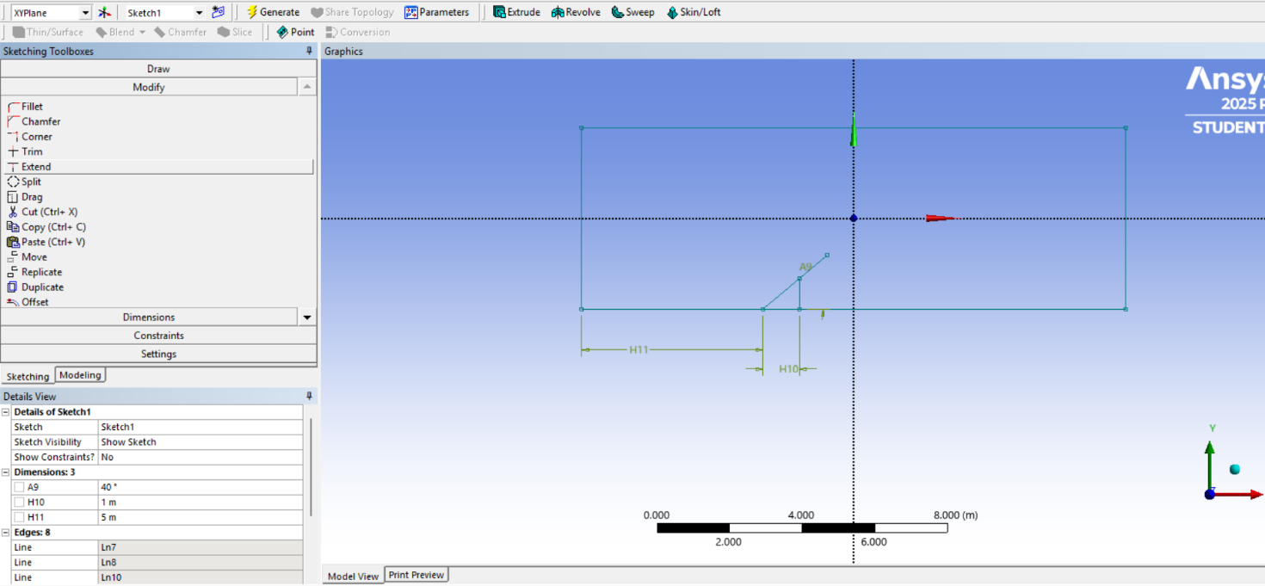
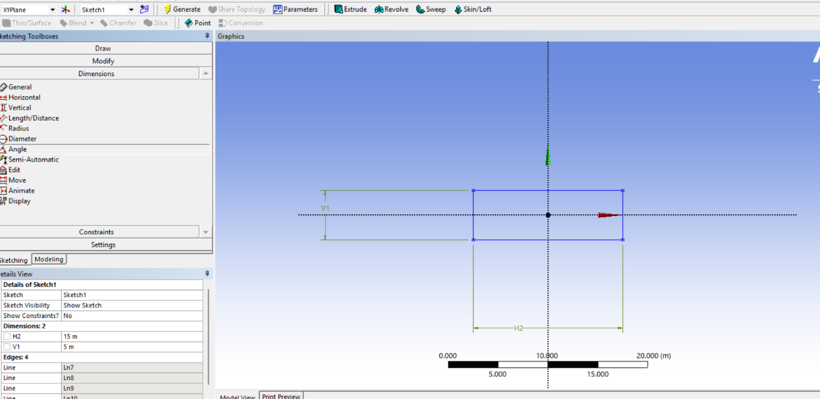

Image of Meshing or Grid generation
Fluid domain |  |  |  | Near wall region
With mesh  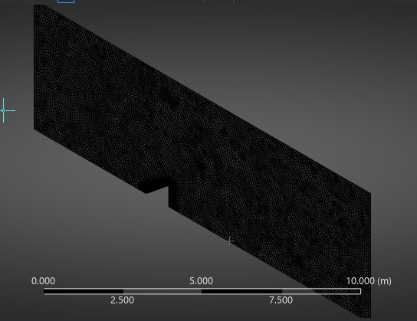 |  |  |  | With triangle  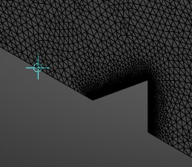
Boundary Conditions
Slover |  |  |  | ANSYS
Turbulence model |  |  |  | k–ω SST
Mach number |  |  |  | 1.75, 2.25, 2.75, & 3.25
Inlet |  |  |  | Pressure Far-Field
Outlet |  |  |  | Pressure Far-Field
Wall |  |  |  | Wall (No-Slip)
Results
Parameter |  |  | Analytical Results |  |  | Numerical Results
β |  |  | NA, NA , NA ,NA |  |  | NA, NA, NA, NA
p₂ |  |  | NA, NA, NA, NA |  |  | 220, 305, 450,600(kPa)
T₂ |  |  | NA, NA, NA, NA |  |  | 325,355,400,450(kelvin)
M₂ |  |  | NA, NA, NA, NA |  |  | 1.25,1.55,1.85,2.10
p₀₂ |  |  | NA, NA, NA, NA |  |  | 260,455,790,1180(kPa)
T₀₂ |  |  | T₀₁ (ISENTROPIC) |  |  | 369.3, 440.3, 524.3,621.2(kelvin)
Pressure contour
Case 1  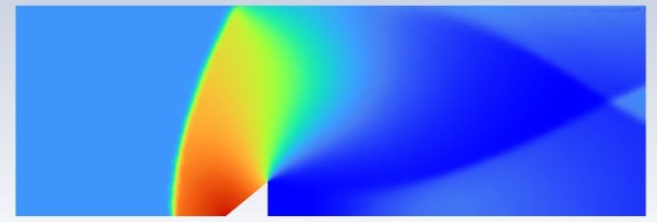 |  |  |  | Case 2  
Shockwave developed | Attached or Detached |  |  | Shockwave developed |  |  | Attached or Detached
Case 3  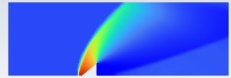 |  |  |  | Case 4  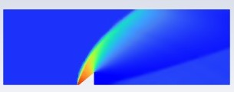
Shockwave developed |  | Attached or Detached |  | Shockwave developed |  |  |  | Attached or Detached

Velocity contour
Case 1  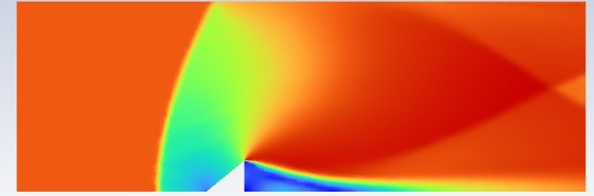 | Case 2  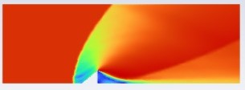
Case 3  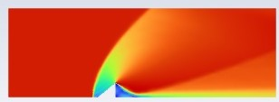 | Case 4  
References:

Simulations Rubric
STUDENT NAME | LOCHANA BC
USN | 1NT23AE053
SEMESTER & SECTION | 5 TH SEMESTER/’A’ SECTION
DEPARTMENT | DEPARTMENT OF AERONAUTICAL ENGINEERING
COURSE TITLE | AERODYNAMICS-II
COURSE CODE | 22AE51A
FACULTY NAME | SIDDALINGAPPA P K

Criteria | Elements Assessed
Model Development | Completeness of the model, appropriateness of assumptions, clarity of objectives.
Simulation Accuracy | Correctness of inputs, accurate outputs, alignment with real-world conditions.
Analysis of Results | Interpretation of simulation outcomes, validity of conclusions, insightfulness of recommendations.
Visualization and Reporting | Clarity of charts/graphs, quality of documentation, logical flow of reporting.


Max Marks | Assessment  Criteria | 100%  (Excellent) | 75% (Proficient) | 50%  (Satisfactory) | 25%  (Developing) | 0%  (Absent/  Incorrect) | Marks  Obtained
 | Model  Development | Exceptionally detailed and precise model. | Comprehensive and effective model. | Functional model, some gaps. | Basic model, lacks clarity. | No model created.
 | TICK (✓)
 | Simulation Accuracy | Fully accurate, real world applicability. | Mostly accurate, aligns well. | Partially accurate, minor gaps. | Minimal accuracy, flawed inputs. | No results or highly inaccurate.
 | TICK (✓)
 | Analysis of Results | Insightful and impactful conclusions. | Detailed and logical analysis. | Basic analysis, some errors. | Minimal analysis, vague conclusions. | No analysis provided.
 | TICK (✓)
 | Visualization and Reporting | Exceptionally detailed and professional. | Clear and professional. | Adequate visuals, minor lapses. | Basic visuals, lacks clarity. | No visuals or poor reporting.
 | TICK (✓)

Max  Marks |  | Marks  Obtained |  | Student Signature |  | Faculty Signature

Simulations Rubric
STUDENT NAME | NOOR FATHIMA
USN | 1NT23AE068
SEMESTER & SECTION | 5 TH SEMESTER/’A’ SECTION
DEPARTMENT | DEPARTMENT OF AERONAUTICAL ENGINEERING
COURSE TITLE | AERODYNAMICS-II
COURSE CODE | 22AE51A
FACULTY NAME | SIDDALINGAPPA P K

Criteria | Elements Assessed
Model Development | Completeness of the model, appropriateness of assumptions, clarity of objectives.
Simulation Accuracy | Correctness of inputs, accurate outputs, alignment with real-world conditions.
Analysis of Results | Interpretation of simulation outcomes, validity of conclusions, insightfulness of recommendations.
Visualization and Reporting | Clarity of charts/graphs, quality of documentation, logical flow of reporting.


Max Marks | Assessment  Criteria | 100%  (Excellent) | 75% (Proficient) | 50%  (Satisfactory) | 25%  (Developing) | 0%  (Absent/  Incorrect) | Marks  Obtained
 | Model  Development | Exceptionally detailed and precise model. | Comprehensive and effective model. | Functional model, some gaps. | Basic model, lacks clarity. | No model created.
 | TICK (✓)
 | Simulation Accuracy | Fully accurate, real world applicability. | Mostly accurate, aligns well. | Partially accurate, minor gaps. | Minimal accuracy, flawed inputs. | No results or highly inaccurate.
 | TICK (✓)
 | Analysis of Results | Insightful and impactful conclusions. | Detailed and logical analysis. | Basic analysis, some errors. | Minimal analysis, vague conclusions. | No analysis provided.
 | TICK (✓)
 | Visualization and Reporting | Exceptionally detailed and professional. | Clear and professional. | Adequate visuals, minor lapses. | Basic visuals, lacks clarity. | No visuals or poor reporting.
 | TICK (✓)

Max  Marks |  | Marks  Obtained |  | Student Signature |  | Faculty Signature

Simulations Rubric
STUDENT NAME | PREYA DEVI
USN | 1NT23AE073
SEMESTER & SECTION | 5 TH SEMESTER/’A’ SECTION
DEPARTMENT | DEPARTMENT OF AERONAUTICAL ENGINEERING
COURSE TITLE | AERODYNAMICS-II
COURSE CODE | 22AE51A
FACULTY NAME | SIDDALINGAPPA P K

Criteria | Elements Assessed
Model Development | Completeness of the model, appropriateness of assumptions, clarity of objectives.
Simulation Accuracy | Correctness of inputs, accurate outputs, alignment with real-world conditions.
Analysis of Results | Interpretation of simulation outcomes, validity of conclusions, insightfulness of recommendations.
Visualization and Reporting | Clarity of charts/graphs, quality of documentation, logical flow of reporting.


Max Marks | Assessment  Criteria | 100%  (Excellent) | 75% (Proficient) | 50%  (Satisfactory) | 25%  (Developing) | 0%  (Absent/  Incorrect) | Marks  Obtained
 | Model  Development | Exceptionally detailed and precise model. | Comprehensive and effective model. | Functional model, some gaps. | Basic model, lacks clarity. | No model created.
 | TICK (✓)
 | Simulation Accuracy | Fully accurate, real world applicability. | Mostly accurate, aligns well. | Partially accurate, minor gaps. | Minimal accuracy, flawed inputs. | No results or highly inaccurate.
 | TICK (✓)
 | Analysis of Results | Insightful and impactful conclusions. | Detailed and logical analysis. | Basic analysis, some errors. | Minimal analysis, vague conclusions. | No analysis provided.
 | TICK (✓)
 | Visualization and Reporting | Exceptionally detailed and professional. | Clear and professional. | Adequate visuals, minor lapses. | Basic visuals, lacks clarity. | No visuals or poor reporting.
 | TICK (✓)

Max  Marks |  | Marks  Obtained |  | Student Signature |  | Faculty Signature

